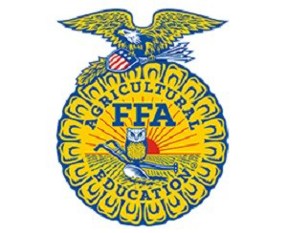
Dear Potential Sponsor,

The Pine View Middle FFA has been a part of our community for many years. Over the past years, our program has impacted the lives of over 100 middle school students per year. Our motto is: “Learning to Do, Doing to Learn, Earning to Live, Living to Serve,” and members of our chapter live by this statement in order to improve our chapter, school, and community.

This year, our chapter’s theme is “Be The Difference”, and we believe that FFA allows our students to be just that. Pine View Middle FFA have the opportunity, through our program, to make a difference in the lives of community members, make a difference in agriculture, and make a difference through their own talents. These students learn about agriculture, leadership, and community service.

Our goal is for each student that is enrolled in agriculture education classes at Pine View Middle School to have an equal opportunity to be involved in this student-led organization. FFA is a self-funded program. Without these funds, our chapter is not able to participate in activities that will allow our students to be the difference our community needs. In order to make this possible, we are seeking program sponsors who are stakeholders in our community and the local agriculture industry. With your support, each student in our program will be able to be involved in an organization that promotes premier leadership, personal growth, and career success.

Your one-time sponsorship would be used with the sole-purpose of ensuring that each student is able to be the difference our community needs through community service and leadership opportunities. In return for your support, your company or organization logo will be included on the back of each t-shirt of over 40 FFA members. Your donation would allow students to have more opportunities that could affect their future for the better. This can also be a unique advertising venture for your group with a relatively small investment. Over 40 students and parents will be wearing your logo on average once per week. It is a simple, yet effective advertising technique. Here is how you can get started.

There are 20 available sponsorship spots. The donation of $50 would secure your 1.5”x1.5” logo. The donation of $100 would secure your 3” x 3” logo. Due to having the shirt designed and printed we ask that sponsorships be returned by 9/1/18.

We would appreciate your support no matter how big or small. If you are interested in supporting our cause, please kindly contact Kelly Bonin, Pine View Middle FFA Advisor, at Kjbonin@pasco.k12.fl.us. Checks can be made payable to Pine View Middle FFA.

Sincerely,

Kelly Bonin, Advisor
Pine View Middle FFA

